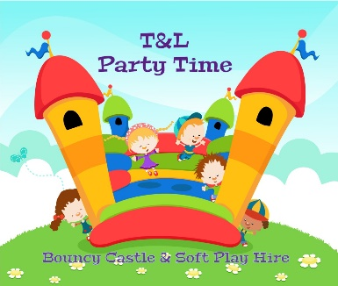
T&L Party Time Disclaimer

IMPORTANT NOTICE Provided that the equipment is used in accordance
with the above guidelines and conditions of hire, those using the inflatable
should do so safely. However, accidents can happen. T&L Party Time can
accept no liability for injuries sustained or any other loss, howsoever
caused, in the absence of the negligence of (your company name) or its
employees. As the equipment will be in the hirer’s possession and control
whilst in use rather than T&L Party Time, any liability for injuries or
other losses caused other than in the circumstances described above rests
with the hirer. Accordingly, it is strongly recommended that the hirer
adequate public liability insurance covering his
or her liability arising from the use of the inflatable.
--------------------------------------------------------------------------------------------------------------------------------------------------------------------------------------------------------------------------------------------------

TERMS AND CONDITIONS OF HIRE

If the Hirer is in any doubt as to the meaning of the following, a representative from
T&L Party Time should immediately be consulted.

THE HIRER will, during the period of the hiring, be responsible for the supervision
of the equipment, its care, safety from damage however slight of any sort, and the
behaviour of all persons of all ages using the equipment whatever their capacity,
including proper supervision of children to ensure children under school age use
the equipment separately to older children or adults.

MAXIMUM AGE allowed to use this equipment is ______ years and under, failure
to observe this limit at any time during the hire period will render the hirer liable
for associated repair costs.

THE HIRER shall not use the equipment for any purpose other than that described
in the hiring agreement, and shall not sub-hire or use the equipment or allow the
equipment to be used for any unlawful purpose or in any unlawful way, nor allow
anyone onto the equipment wearing shoes, spectacles, carrying sharp objects,
key-rings, metal studded clothing or any other similar items which could cause
damage to others or the equipment. No food or drink is to be taken onto or
consumed on the equipment. No Party Poppers, Coloured streamers or Silly
String should be taken, thrown or sprayed onto the equipment, these materials
permanently stain the material and the hirer will be liable to compensate
T&L Party Time in the event of damage.

THE HIRER shall be deemed to have inspected the equipment
(accessories and trailer(s) if supplied) and to have agreed that it is supplied
in good condition unless he/she brings to the attention of T&L Party Time
when it is set up and checked by the hirer when coming in to possession
of the equipment any faults noted by the Hirer.

THE HIRE PERIOD unless otherwise agreed is from delivery until ________ or after
at the discretion of T&L Party Time. Any obstruction by the hirer or their
guests causing unnecessary delay will be charged at £35 per hour or part of,
this also applies where ballpit balls are not bagged and ready for collection.

PUBLIC LIABILITY INSURANCE is excluded in its entirety following any claim
or injury to any third party or employee whether directly or indirectly related to
the use of drugs and/or alcohol. T&L Party Time excludes any liability
for injury loss or damage caused to any person using the equipment contrary
to the terms and conditions of this contract

IMPORTANT NOTICE Provided that the equipment is used in accordance with
the above guidelines and conditions of hire, those using the inflatable should
do so safely. However, accidents can happen. T&L Party Time can accept
no liability for injuries sustained or any other loss, howsoever caused, in the
absence of the negligence of T&L Party Time or its employees. As the
equipment will be in the hirer’s possession and control whilst in use rather than
T&L Party Time, any liability for injuries or other losses caused other than
in the circumstances described above rests with the hirer. Accordingly, it is strongly
recommended that the hirer has adequate public liability insurance covering his
or her liability arising from the use of the inflatable.

I DECLARE that I have read and understand these terms and conditions of hire
and any relevant operating and safety instructions supplied with the equipment,
and I sign the contract fully aware of the implications and responsibilities
placed upon me by doing so.

SIGNED

PRINT

DATE

